Day 23 REPORT
TASK - Employee Relationship Building and Dashboard Creation in Power BI
Objective
The objective of this session was to build relationships between employee datasets and create a dashboard in Microsoft Power BI using employee-related data.

Datasets Used
Two datasets were used:
1. Employee_Table
Contains:
- Employee_ID
- Employee_Name
- Department_ID
- Department_Name
- Project_ID
- Project_Name
- Salary
2. Employee_Details
Contains:
- Employee_ID
- Email
- Phone
- Attendance
- Experience_Years
- Department_ID
- Project_ID

Relationship Building
Relationships were created in:
Model View
using common columns between the two tables.
The following relationship types were created:
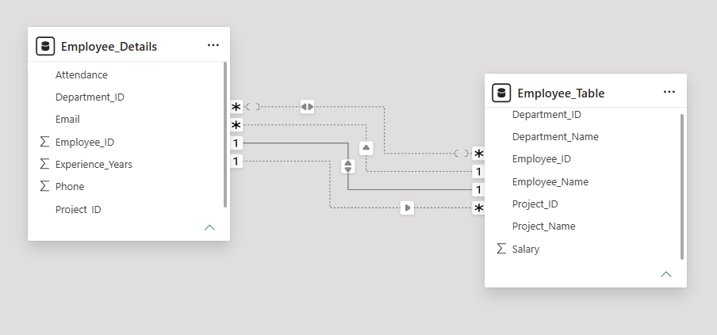

1. One-to-Many Relationship
Connection:
Employee_Table.Employee_ID
→
Employee_Details.Employee_ID
Explanation:
One employee contains multiple detail records.

2. Many-to-One Relationship
Connection:
Employee_Details.Department_ID
→
Employee_Table.Department_ID
Explanation:
Many employees belong to one department.

3. Many-to-Many Relationship
Connection:
Employee_Table.Project_ID
↔
Employee_Details.Project_ID
Explanation:
Multiple employees can work on multiple projects.

Dashboard Creation
After building relationships, a dashboard was created using different visualizations for employee analysis.

Visualizations Used
1. Bar Chart
Purpose:
Count of Project_ID by Project_Name
Projects displayed:
- AI System
- Web App
- Mobile App
- Payroll System

2. KPI Cards
The following KPI cards were created:
KPI | Value
Sum of Salary | 525K
Sum of Experience_Years | 34

3. Area Chart
Purpose:
Count of Project_Name by Department_ID
Departments:
- D1
- D2
- D3

4. Pie Chart
Purpose:
Sum of Salary by Department_Name
Departments displayed:
- HR
- IT
- Finance

5. Funnel Chart
Purpose:
Count of Attendance by Department_ID
Attendance comparison was shown for:
- D1
- D2
- D3

Features Used
Dark Theme Dashboard
A dark blue dashboard theme was applied for visualization.
Interactive Charts
Visuals dynamically displayed employee information and analysis.
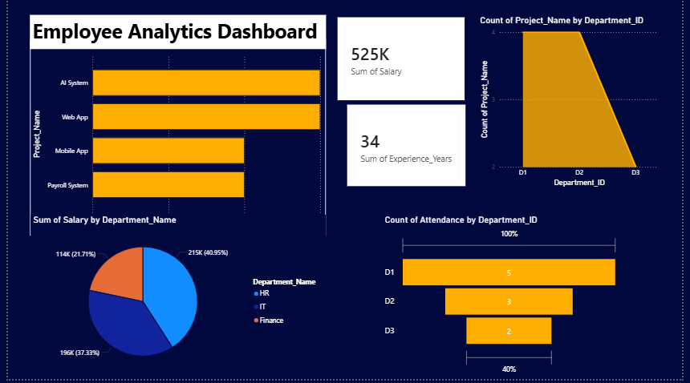

Conclusion
In this session, relationships between Employee_Table and Employee_Details were successfully created in Power BI using Model View. Different relationship types such as One-to-Many, Many-to-One, and Many-to-Many were implemented. A dashboard was also created using bar charts, KPI cards, pie charts, area charts, and funnel charts to analyze employee data effectively.

